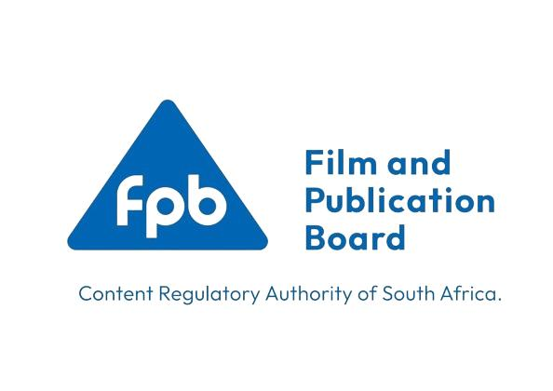
PRESS RELEASE
IMMEDIATE RELEASE
03 February 2026

Film and Publication Board and Mahikeng Local Municipality Champion Safer Digital Platforms for Children

Mahikeng, North West – The Film and Publication Board (FPB), in partnership with the Mahikeng Local Municipality, will host a series of awareness-raising activities to commemorate Safer Internet Day (SID). The initiative aims to promote safer digital platforms and strengthen the protection of children in the online environment, under the theme “Smart tech, safe choices - Exploring the safe and responsible use of Artificial Intelligence”.
Safer Internet Day is commemorated annually on the second Tuesday of February in approximately 180 countries worldwide. The initiative brings together young people, parents, caregivers, educators, policymakers, law enforcement, and industry stakeholders under a common global vision of creating a better and safer internet for all, with a particular focus on children and young people.
As internet access continues to expand across South Africa, children face increasing exposure to online risks, including harmful and age-inappropriate content, cyberbullying, online grooming, sexual exploitation, and the circulation of Child Sexual Abuse Material (CSAM). Emerging technologies, including generative Artificial Intelligence (AI), have further intensified these risks, making public awareness, education, and coordinated action more critical than ever.
“While digital technologies offer immense opportunities for learning, creativity, and connection, if not properly managed, they also expose children to serious online harms,” says Adv. Norman Gidi, Chief Executive Officer of the FPB. “Safer Internet Day serves as a vital platform to raise awareness, empower communities, and strengthen digital citizenship to ensure that children are protected in the digital space.”
In the lead-up to the main event, the FPB and Mahikeng Local Municipality will conduct engagements with learners, law enforcement agencies, community members, and digital content creators, focusing on online safety, responsible digital behaviour, and child protection.

Event Details
Safer Internet Day Commemoration – Main Event
Date: 10 February 2026
Time: 09h00 – 14h00
Venue: Mahikeng Civic Centre
Members of the media are invited to attend and cover the event.

ENDS

For media enquiries or interviews, please contact:
Ms Manala Botolo
Assistant Manager Communications and Marketing
Email: manala.botolo@fpb.org.za
Cell: 082 860 6748

